W2 HTML: Common and Semantic Elements

Overview
HTML describes the structure of a web page document. The structure is made up of categories of elements including the following content items: metadata, section, heading, phrasing, embedded, and interactive elements. Some elements are associated with forms and tabular data. You are not expected to memorize all HTML tags. Rather, become familiar with the most commonly used elements and be able to reference others through viable sources.

Prepare
You have already applied some basic HTML to your home page including required, head content. In this activity, let us formally list some basic HTML concepts and elements that you will use in your current work in this class.
HTML BASICS - w3schools.com
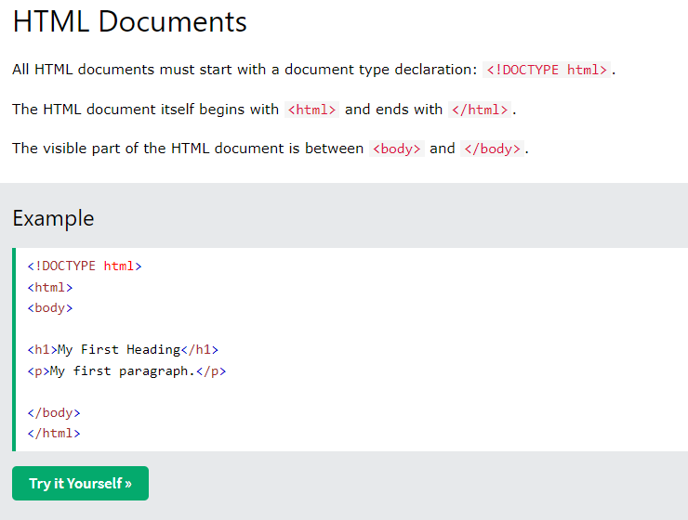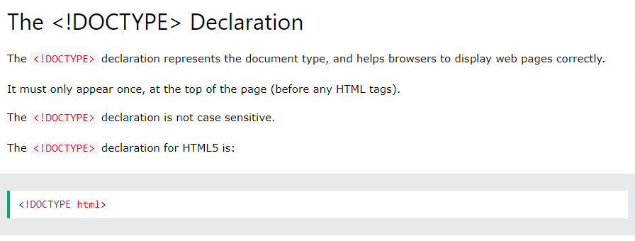

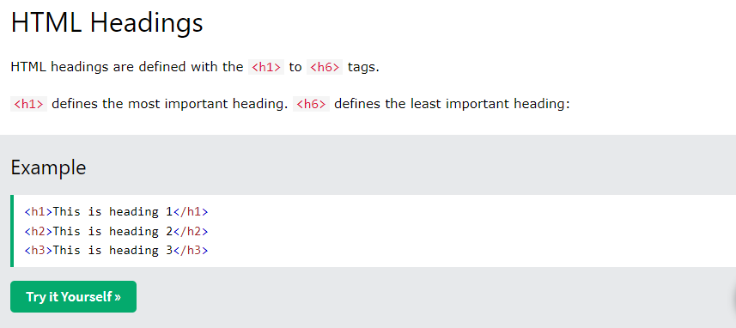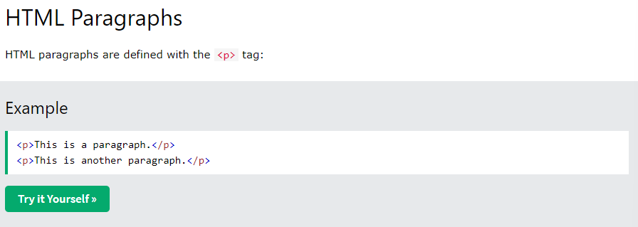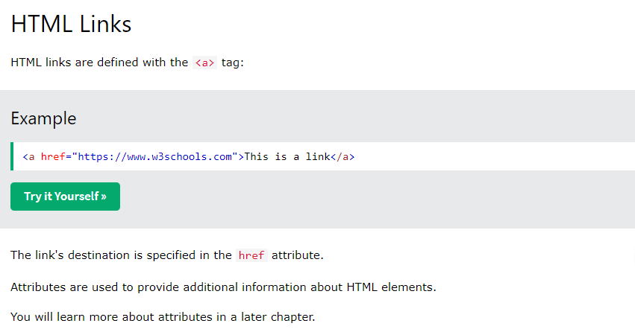
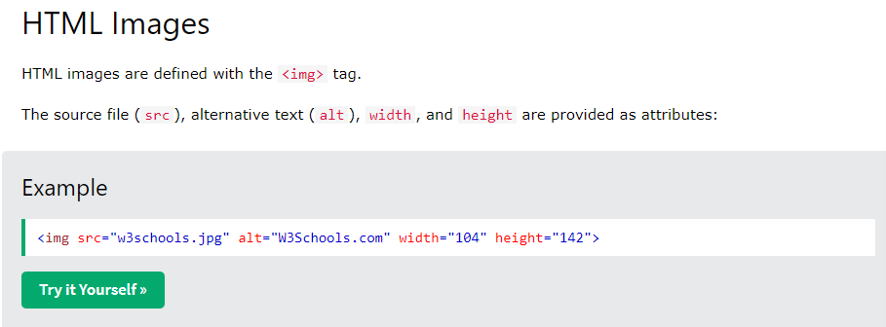
HTML SEMANTC ELEMENTS - w3schools.com
